GUYANA
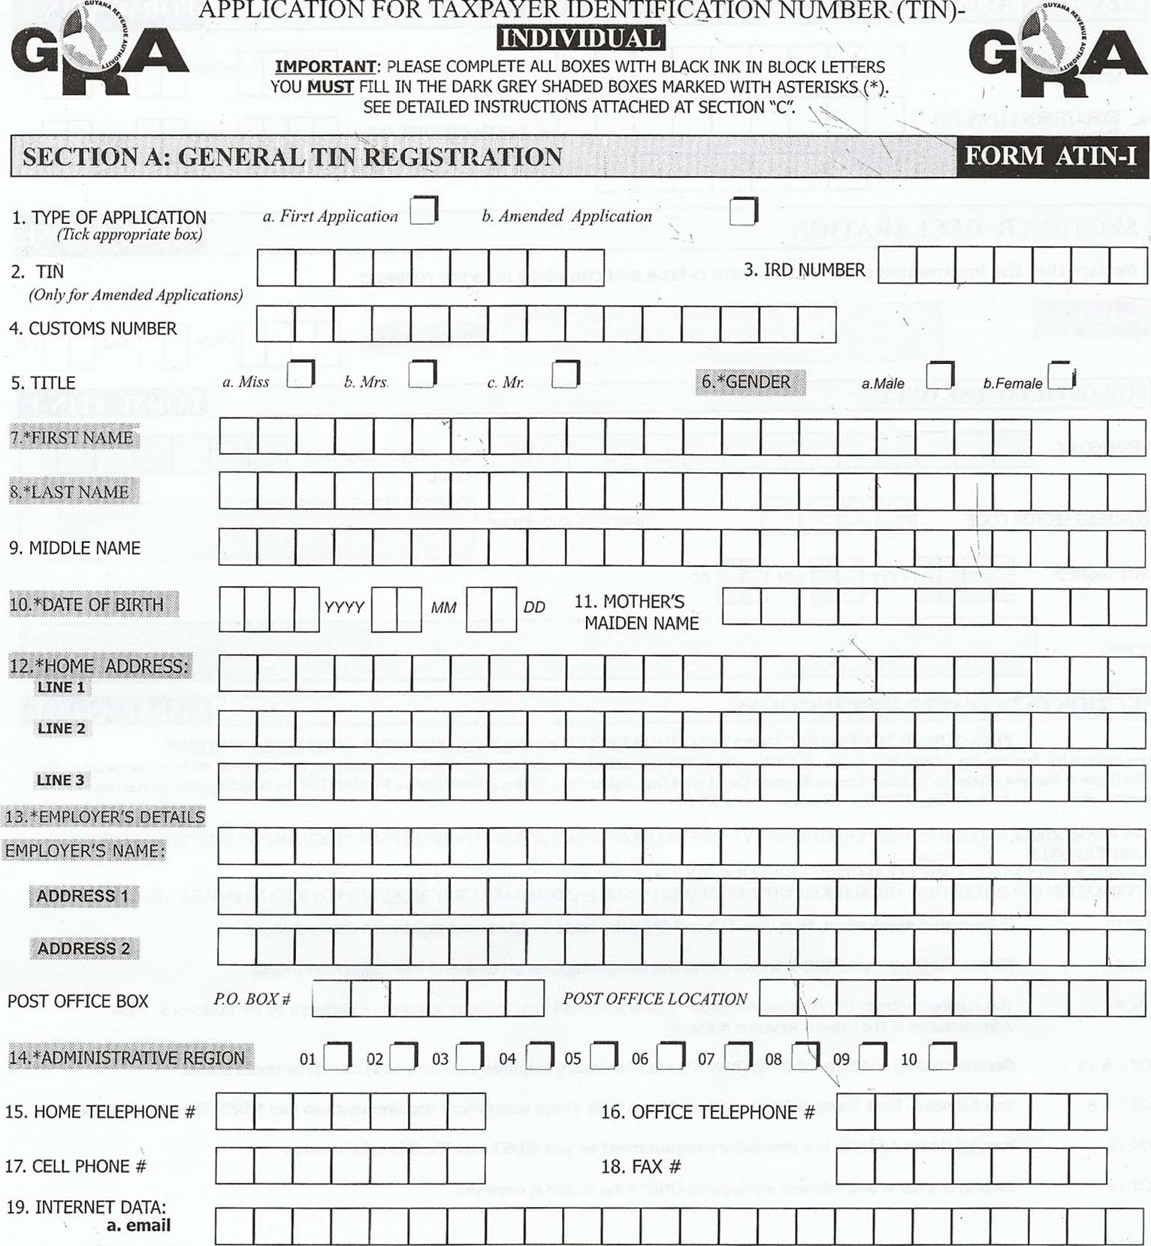
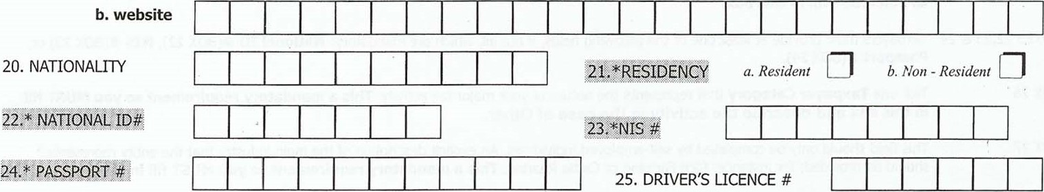
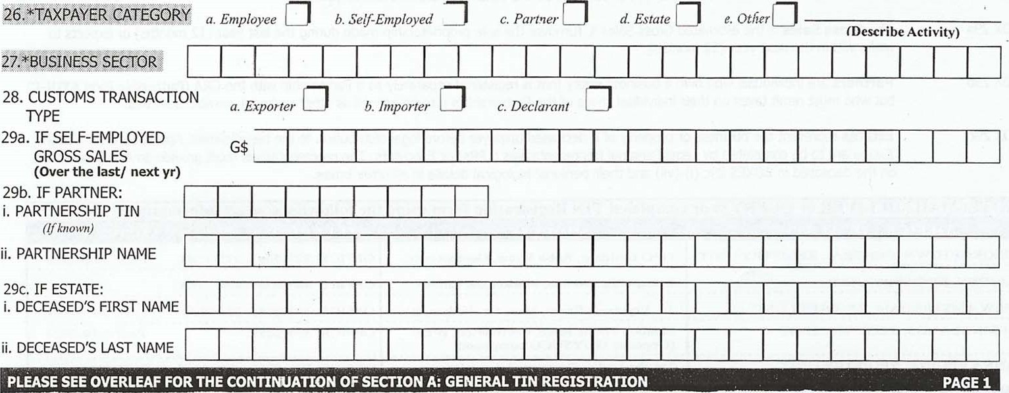
a
Partner
SECTION A: GENERAL TIN REGISTRATION CONTINUED |  | FORM ATIN-I
iii. DECEASED'S TIN (Ifknovvn)  v. EXECUTOR'S \ CPR's TIN (Ifknown) vii. DEATH CERTIFICATE | iv. DATE OF DEATH  vi. DEATH CERTIFICATE  DATE ISSUED
SECTION B: DECLARATION |  | FORM ATIN-I
I declare that the information given in this form is true and complete in every respect:
*APPLICANT'S
*DATE SIGNED
FOR OFFICIAL USE ONLY |  | FORM ATIN-I
TAX OFFICE LOCATION
VERIFIED BY
CODE
BUSINESS SECTOR CODE  DATE SIGNED  NOTES | OFFICER'S SIGNATURE
SECTION C: TAXPAYER INSTRUCTIONS |  | FORM ATIN-I

PLEASE READ THE INSTRUCTIONS BELOW CAREFULLY TO HELP YOU PROPERLY COMPLETE THIS FORM
According to the Income Tax (Amendnlent) (No.2)Act No. 15 of' 2006, all Individuals and Companies that transact business, that is, submit returns or payments, to the GRA (Internal Revenue, Customs, VAT, and Licence Revenue Dept.) must first register for a Taxpayer Identification Number (TIN) by completing the the relevant registration form/s -Individual(Form ATIN-I) or Company(Form ATIN-C).
THIS FORM, ATiN-1, SHOULD BE COMPLETED BY EMPLOYEES, SELF-EMPLOYED, BUSINESS PARTNERS AND EXECUTORS OF ESTATES OF DECEASED TAXPAYERS ONLY.
ALL APPLICANTS MUST COMPLETE SECTION A (GENERAL TIN REGISTRATION) AND SECTION B (DECLARATION).
OFFICE LOCATION | ADDAESS | 'TELEPHONE AND FAX NUMBER
GEORGETOWN, CENTRAL REGISTRY UNIT | GPO Building, Robb Street, Georgetown. | OFFICE: 225-5587, 225-4584 | FAX: 225-5588
LINDEN, REGISTRY UNIT | 2 Republic Avenue, Mackenzie, Linden. | OFFICE: 444-6341, 444-4163
NEW AMSTERDAM, REGISTRY UNIT | 14 Vryman's Erven, New Amsterdam, B 'ce. | OFFICE. -2955, 333-2948 | FAX: 333-4899
SPRINGLANDS, REGISTRY UNIT | Skeldon Public Road, Corriverton, B'ce.  (Opposite GL_JYSUCO compound) | OFFICE: 339-2659, | FAX: 339-2324
ANNA REGINA, REGISTRY UNIT | Takuba Lodge Compound,Anna Regina, Essequibo Coast. | OFFICE: 771-5266, 771-5267 | FAX: 771-4953
PLEASE COMPLETE AND DELIVER TO THE OFFICE NEAREST TO You! |  |  | PAGE 2
INFORMATION FOR BOXES THAT ARE MARKED WITH ASTERISKS AND SHADED DARK GREY MUST BE PROVIDED TO ENSURE REGISTRATION.
BOX 1b  BOX 2  BOX 6 & 10  BOX 7 & 8  BOX 12  BOX 13  BOX 14 | If Amended Application, fill in your TIN and ONLY the boxes for which your registration details changed.  Fill this box ONLY if your TIN is known due to this being an application to amend your registration details.  This number refers to the ASYCUDA number that is assigned to any importer, exporter or declarant by the Customs & Trade Administration of the Guyana Revenue Authority.  Gender (BOX 6) and Date of Birth (BOX 10) are mandatory requirements so you MUST fill in these boxes.  Your full name, First Name (BOX 7) and Last Name (BOX 8) are mandatory requirements so you MUST fill in these boxes  Your full Home Address is a mandatory requirement so you MUST provide this information.  Employer's name and address are required ONLY if the person is employed.  Indicate by a tick, one of the ten(10) Administrative Regions of Guyana where you are located. This is a mandatory requirement
so you MUST fill in this box.
BOXES 22,23 & 24 Taxpayers must provide at least one of the following fields, if not all, which are mandatory: National ID #(BOX 22), NIS #(BOX 23) or Passport #(BOX 24).
BOX 26  BOX 27  BOX 28  BOX 29a  BOX 29b  BOX 29c | Tick one Taxpayer Category that represents the nature of your major tax activity. This a mandatory requirement so you MUST fill in this box and describe the activity in the case of Other.  This field should only be completed by self-employed individuals. An explicit description of the main industry that the entity represents should be provided; for instance: Rice Farming or Cattle Rearing. This a mandatory requirement so you MUST fill in this box.  In this Customs Transaction Type, you should tick all the boxes that are relevant to you.  The Gross Sales is the estimated Gross Sales \ Turnover the sole proprietorship made during the last year (12 months) or expects to make within the next year (12 months).  Partners are individuals who own a business entity that is registered separately as a Partnership with the GRA (Partnership Form ATIN-C) but who must remit taxes on their individual share of the Partnership's income as well as other personal taxable activities.  Estates represent the business or property of a deceased taxpayer before legal distribution to the beneficiaries. Applications for TIN for Estates are to be completed by Legal Personal Representatives (LPRs) or Executors. The representatives must provide limited information on the deceased in BOXES 29c (i)-(vii) and their personal biological details in all other boxes.
NOTE: MAIL DELIVER or UERY our com leted TIN Re •stration form usin the followin contact information:

