GUYANA
COMPANY / PARTNERSHIP
APPLICATION FOR TAXPAYER IDENTIFICATION NUMBER (TIN)-
IMPORTANT: PLEASE COMPLETE ALL BOXES WITH BLACK INK IN BLOCK LÜTERS YOU MUST FILL IN THE DARK GREY SHADED BOXES MARKED WITH ASTERISKS SEE DETAILED INSTRUCTIONS ATTACHED AT SECTION c .
1. TYPE OF APPLICATION
a.
First
(Tick appropriate box)
PLEASE SEE OVERLEAF FOR THE CONTINUATION OF SECTION A: GENERAL TIN REGISTRATION PAGE 1
2. TAXPAYER ID NUMBER - TIN (Onlyfor Amended Applications)
8. MAILING ADDRESS:
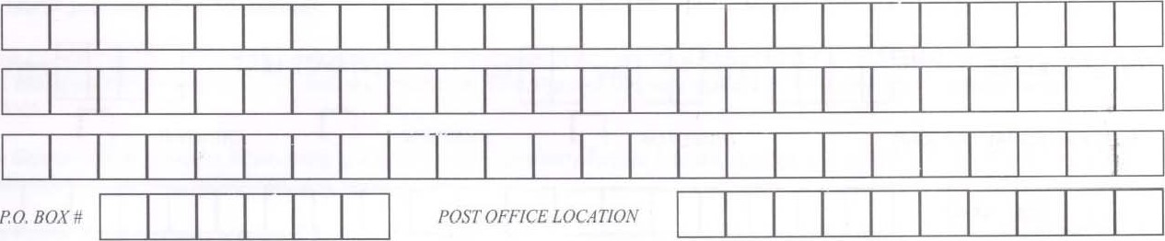
(Ifdifferent)
(LINE 1)
(LINE 2)
(LINE 3)
OR
POST OFFICE BOX
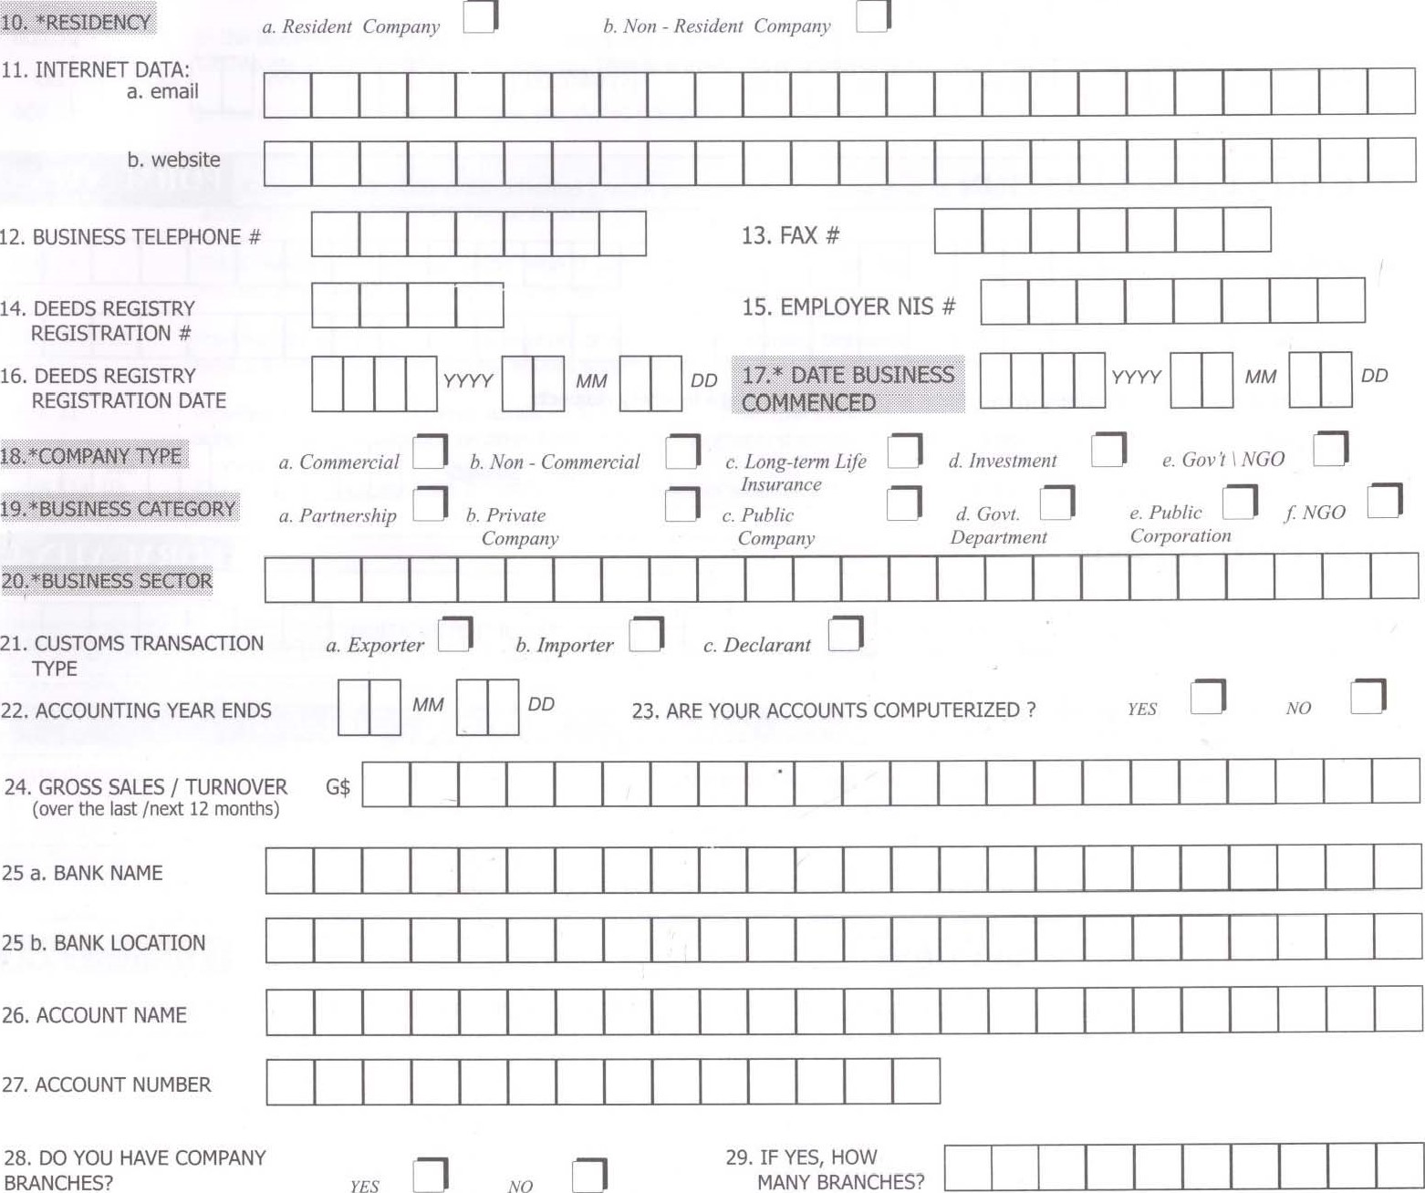
SECTION A: GENERAL TIN REGISTRATION CONTINUED | FORM ATIN-C
30a. BRANCH NAME
BRANCH ADDRESS
(LINE 1)
(LINE 2)
(LINE 3)
30b. BRANCH NAME
BRANCH ADDRESS
(LINE 1)
(LINE 2)
(LINE 3)
31a.(i) PRINCIPAL OFFICER DIRECTOR PARTNER TRUSTEE OTHER
- FULL LEGAL NAME
(First Last Names)
- TIN
(v) DATE LEFT
- DATE JOINED
31b.(i) PRINCIPAL OFFICER DIRECTOR PARTNER TRUSTEE OTHER
- FULL LEGAL NAME
(First & Last Names)
PLEASE SEE OVER LEAF FOR THE CONTINUATION OF SECTION C: TAXPAYER INSTRUCTIONS | PAGE 2
- TIN
(v) DATE LEFT
- DATE JOINED
SECTION B: DECLARATION | FORM ATIN-C
*APPLICANT'S
NAME
*DESIGNATION
I declare that the information given in this form is true and complete in every respect:
*APPLICANT'S
SIGNATURE *DATE SIGNED
FOR OFFICIAL USE ONLY | FORM XI*IN-C
TAX OFFICE LOCATION
VERIFIED BY
CODE
BUSINESS SECTOR CODE OFFICER'S SIGNATURE
DATE SIGNED
NOTES
SECTION C: TAXPAYER INSTRUCTIONS | FORM ATIN-C

PLEASE READ THE INSTRUCTIONS BELOW CAREFULLY TO HELP YOU PROPERLY COMPLETE THIS FORM
According to the Income Tax (Amendment) (No. 2) Act No. 15 of2006, all Individuals and Companies that transact business, that is, submit returns or payments, to the GRA (Internal Revenue, Customs, VAT, and Licence Revenue Dept.) must first register for a Taxpayer Identification Number (TIN) by completing the relevant registration form/s -Individual (Form ATIN-I) or Company (Form ATIN-C).
THIS FORM, ATIN-C, SHOULD BF. COMPLETED BY PARTNERSHIPS. PUBLIC & PRIVATE COMPANIES, GOVERNMENT DEPARTMENTS &PUBLIC CORPORATIONS AND NON-GOVERNMENT ORGANISATIONS ONLY.
ALL APPLICANTS MUST COMPLETE SECTION A (GENERAL TIN REGISTRATION) AND SECTION B (TAXPAYER DECLARATION).
INFORMATION FOR BOXES THAT ARE MARKED WITH ASTERISKS AND SHADED DARK GREY MUST BE PROVIDED TO ENSURE REGISTRATION.

NOTE: MAIL, DELIVER or QUERY your completed TIN Registration form using the following contact information:
BOX 1b BOX 2  BOX 4  BOX 5  BOX 6  BOX 7  BOX 8  BOX 9  BOX 16  BOX 17  BOX 18  BOX 19  BOX 19a  BOX 19d  BOX 19e  BOX 19f  BOX 20  BOX 21  BOX 22  BOX 24  BOXES 28-30  BOX 31  BOX 31a. (i),  31b. (i) | If Amended Application, fill in your TIN and ONLY the boxes for which your registration details changed.  Fill this box ONLY if your TIN is known due to this being an application to amend your registration details.  This number refers to the ASYCUDA number that is assigned to any importer, exporter or declarant by the Customs & Trade Administration of the Guyana Revenue Authority.  The Business Name of the company represents the full legally recognizable title of the business entity. This is a mandatory requirement for all entities so you MUST provide this information.  The Trading Name represents another name besides the Legal or Business Name the entity may be better known as or prefers to use in transacting business. Thus, this box should be filled ONLY if the Legal\Business and Trading Names differ.  The entity's full Business Address is a mandatory requirement so you MUST provide this information.  Mailing Address is required ONLY if the current Business Address differs from the Postal Address. You should PI ovide only ONE form of addressing, that is, EITHER a normal Physical Address OR a 2-part Post Office Address, if necessary.  Indicate by a tick, one of the ten (10) Administrative Regions of Guyana where your Head Office is physically located. This is a mandatory requirement so you MUST fill in this box.  Provide the Date Registered with the Deeds Registry as a business entity. This is a mandatory requirement for registered companies ONLY.  Provide the Date the Business Commenced. This is a mandatory requirement so you MUST provide this information.  Tick ONLY one (1) of the five (5) boxes that best represents the Company Type of your entity. This is a mandatory requirement so you MUST provide this information.  Tick ONLY one (I) of the six (6) boxes that best represents the Business Category of your entity. This is a mandatory requir nt so you MUST provide this information.  NOTE: All Partners to the business MUST complete and submit a separate Individual Registration Form (ATIN-I) to obtain a personal TIN that allows each individual to remit taxes and returns on their share of the partnership's income and other personal taxable transactions.  Tick the Government category if the entity is a Public Sector Company fully or partially funded or controlled by the Government such as Ministries, some Utilities, Authorities, and Agencies, etc.  Tick the Public Corporation category if the entity is a Public Sector organization fully or partially funded or controlled by the Government.  Tick the NGO category if the entity is a Non-Government Organization such as Charities, Trade Unions, Pension Schemes, Trustees, International Organizations, Religious Organizations and other Non-Profit entities.  In the Business Sector box an explicit description of the Main Industry that the entity represents should be provided, for instance: Clothes Manufacturing or Rice Farming, etc. This is a mandatory requirement so you MUST fill in this box.  In this Customs Transaction Type you should tick all the boxes that are relevant to you.  The standard taxation Accounting Period (month and day) across Guyana ends on December 31 every year. If your company's accounting period is different please explicitly specify here.  The Gross Sales/ Turnover is the value of goods and services sold during the last year (12 months) or the value of goods and services the business expects to make within the next year (12 months).  Provision for a count and physical location of any existing Company Branches besides the Business Headquarters. If other Branches exist, the addresses of these other entities should be provided on a supplementary sheet.  Provision for basic identification details on at least two (2) Principal Officers, such as the Directors, Partners or Trustees, from the entity. Additional information on other Existing Company Officers should be provided on a supplementary sheet.  Tick the box to indicate if the Principal Officer, whose information is being supplied, is a Director, Partner or Trustee.

OFFICE LOCATION
GEORGETOWN, CENTRAL REGISTRY UNIT
LINDEN, REGISTRY UNIT
NEW AMSTERDAM, REGISTRY UNIT
SPRINGLANDS, REGISTRY UNIT
ANNA REGINA, REGISTRY UNIT

ADDRESS
GPO Building, Robb Street, Georgetown.
2 Republic Avenue, Mackenzie, Linden.
SECTION C: TAXPAYER INSTRUCTIONS CONTINUED | FORM ATIN-C
PLEASE SUBMIT THE COMPLETE REGISTRATION FORM TO THE GUYANA REVENUE AUTHORITY (GRA) OFFICE NEAREST TO you PAGE 3
14 Vryman's Erven, New Amsterdam, B'ce.

Skeldon Public Road, Corriverton, B'ce. (Opposite GUYSUCO compound)
Takuba Lodge Compound,Anna Regina, Essequibo Coast.

TELEPHONE AND FAX NUMBER
OFFICE: 225-5587, 225-4584 FAX: 225-5588
OFFICE.444-6341, 444-4163
OFFICE: 333-2955, 333-2948 FAX: 333-4899 OFFICE: 339-2659, FAX: 339-2324

OFFICE: 771-5266, 771-5267 FAX: 771-4953

